Hospitality and Tourism

Professional Selling Presentation

Mr. Bodenburg

**THE SITUATION II**

You will assume the role of a catering sales manager for a hotel. A potential client is interested in holding a three-day conference for 750 attendees at the hotel and is meeting with you to determine unique and creative catering options. Each conference attendee’s registration includes two breaks, a seated dinner, a reception and two lunches during the three day conference.

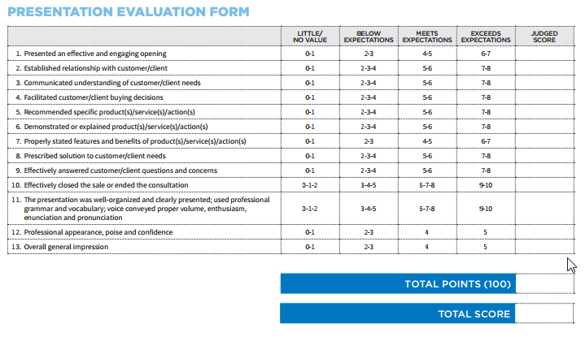

**YOUR ROLE**

* Arrange 3 days of unique and creative food options
  + A reception luncheon or dinner for conference attendees upon arrival
  + Food options for break times
  + Two Lunches
  + A seated dinner
* Include pricing per plate/guest
* Varying Food choices for the client
* Goal is to get a food contract signed for the conference